LAB EXPERIMENT RECORD
SET 8: Employee Performance Analysis
Department | AI&DS
Course Code / Course Name | DSA0602 / Data Handling and Visualization
Experiment | Data Visualization using R
Name | DEVAMADA HEMASREE
Register Number | 192524114
Date | 01 OCTOBER 2026
Day | THURSDAY

SET 8: Employee Performance Analysis
Aim: To visualize employee performance data using a line chart, bar chart, and table in R, and to build an interactive dashboard using Tableau.
Dataset: Employee Performance
Employee ID | Department | Years of Service | Performance Score
1 | Sales | 5 | 85
2 | HR | 3 | 92
3 | Marketing | 7 | 78

PROGRAM 1: Line Chart (Performance Trend)
Aim: To show the performance trend of employees using a line chart.
graphics.off()
emp_id <- c(1, 2, 3)
score <- c(85, 92, 78)

plot(emp_id, score, type = "o", col = "blue", pch = 19,
xaxt = "n", ylim = c(70, 100),
xlab = "Employee ID", ylab = "Performance Score",
main = "Employee Performance Trend")
axis(1, at = 1:3, labels = 1:3)
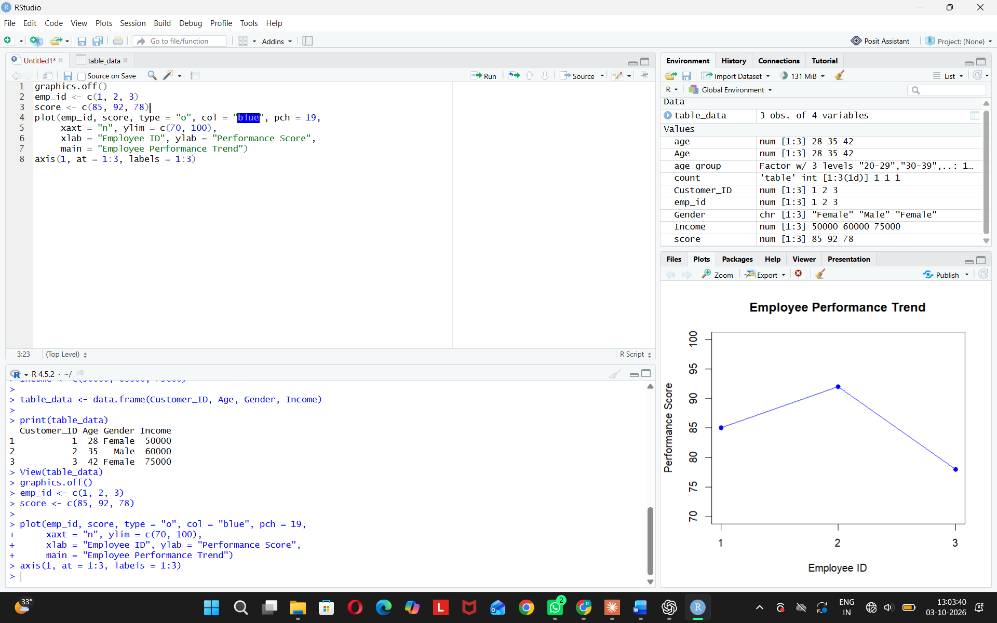
Observation: Employee 2 has the highest score (92). Employee 3 has the lowest (78).
PROGRAM 2: Bar Chart (Employees by Department)
Aim: To show the distribution of employees across departments.
graphics.off()
dept <- c("Sales", "HR", "Marketing")
count <- table(dept)

barplot(count,
xlab = "Department", ylab = "Number of Employees",
main = "Employees by Department",
col = c("lightgreen", "orange", "skyblue"),
ylim = c(0, 2))
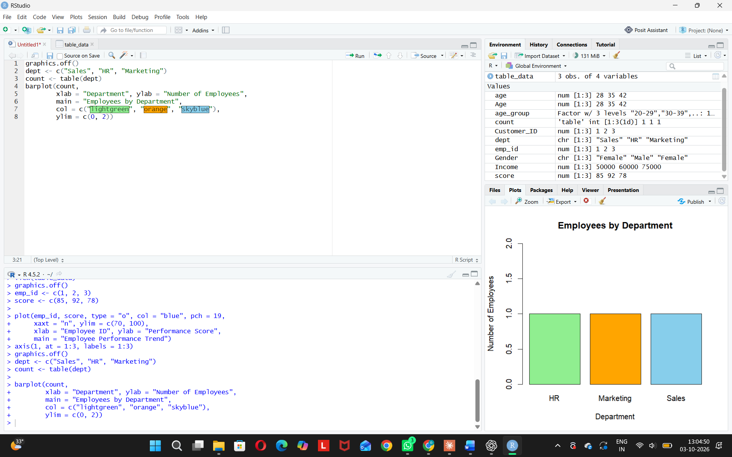
Observation: Each department has one employee, so the distribution is equal.
PROGRAM 3: Table (Performance Data)
Aim: To show the performance data of each employee in a table.
Employee_ID <- c(1, 2, 3)
Department <- c("Sales", "HR", "Marketing")
Years_of_Service <- c(5, 3, 7)
Performance_Score <- c(85, 92, 78)

table_data <- data.frame(Employee_ID, Department,
Years_of_Service, Performance_Score)

print(table_data)
View(table_data)
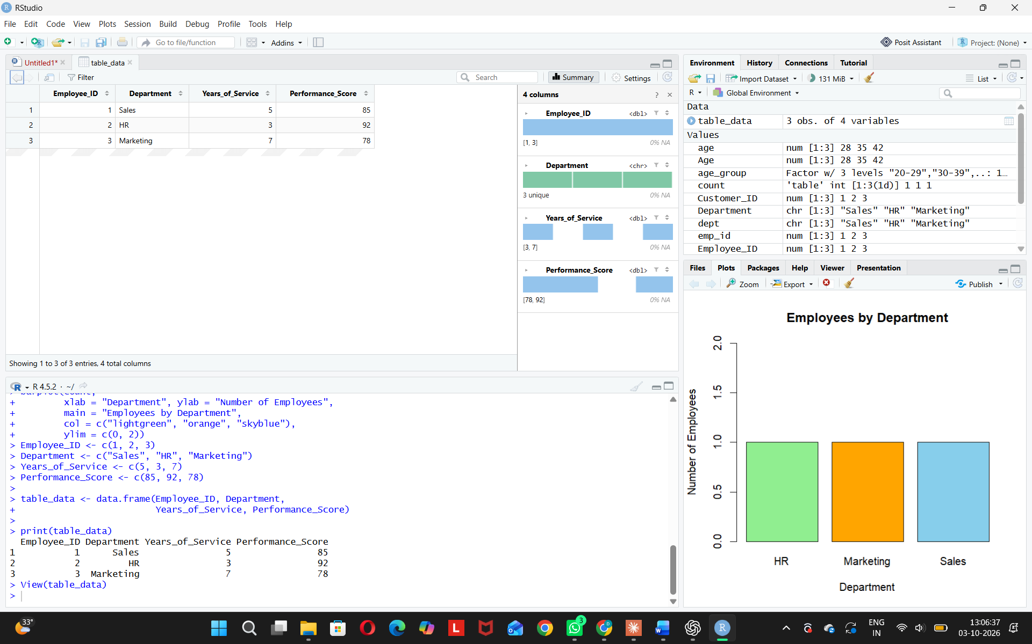 Observation: HR employee has the best score (92) with the least service (3 years). Marketing employee has the most service (7 years) but the lowest score (78).
PROGRAM 4: Tableau Dashboard
Aim: To build an interactive dashboard with the line chart, bar chart, and table in Tableau.
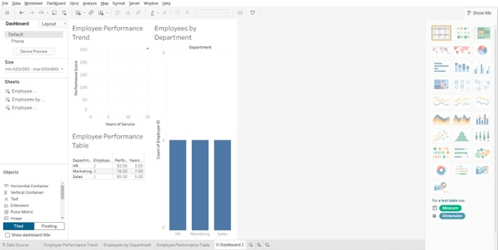
Observation: The user can explore employee performance interactively.

